<Report 1. Test results of programming part>

2016314364 박수헌

1.a.

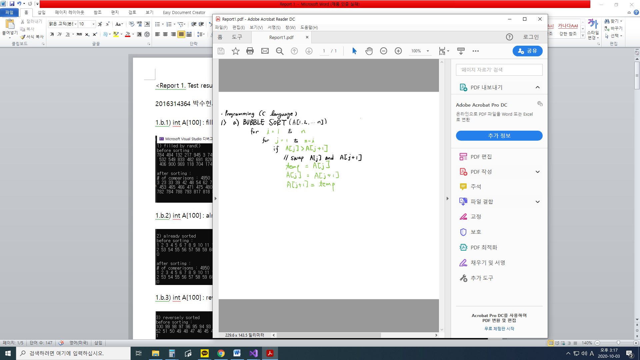

1.b.1) int A[100] : filled by rand()%1000

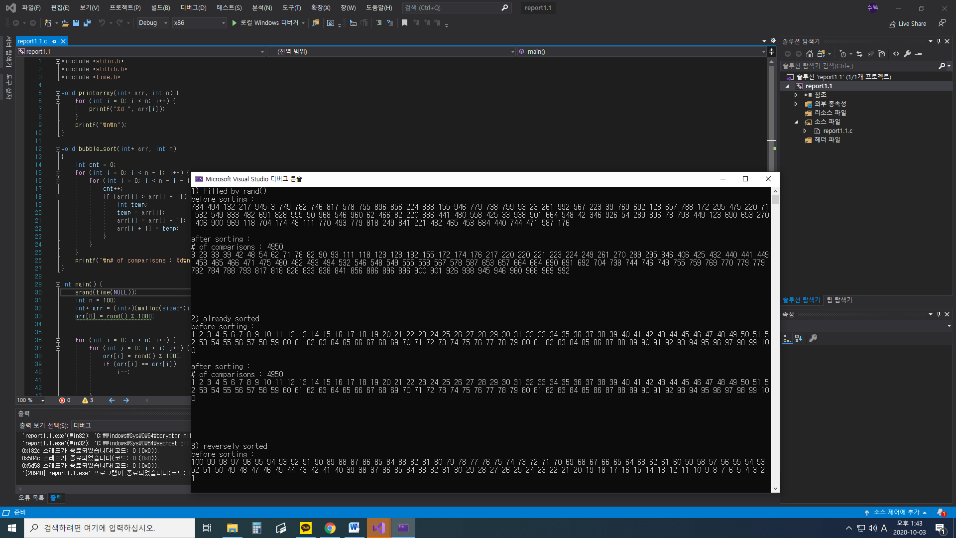

1.b.2) int A[100] : already sorted



1.b.3) int A[100] : reversely sorted

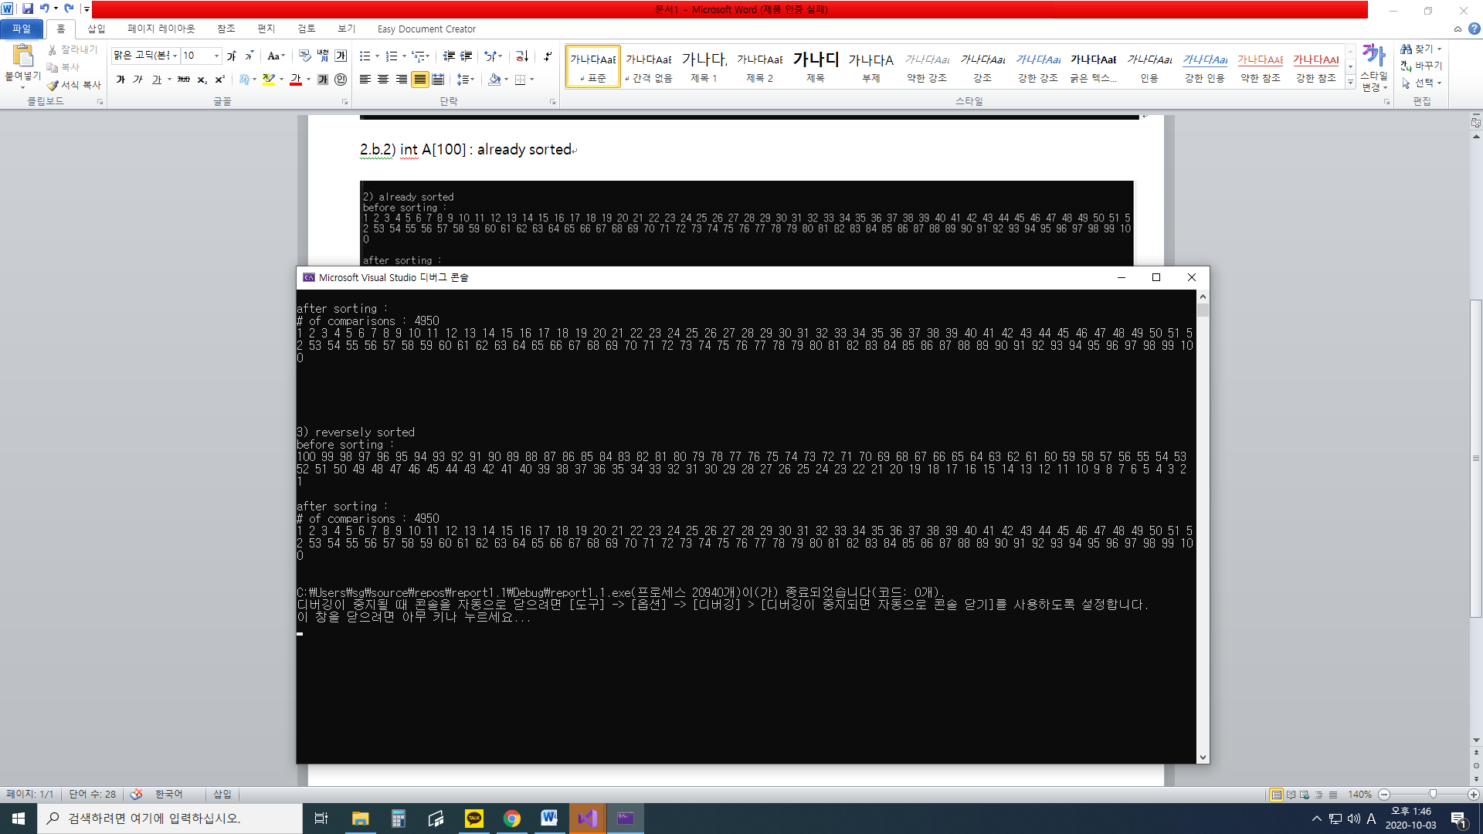

2.1) int A[100] : filled with rand()%1000

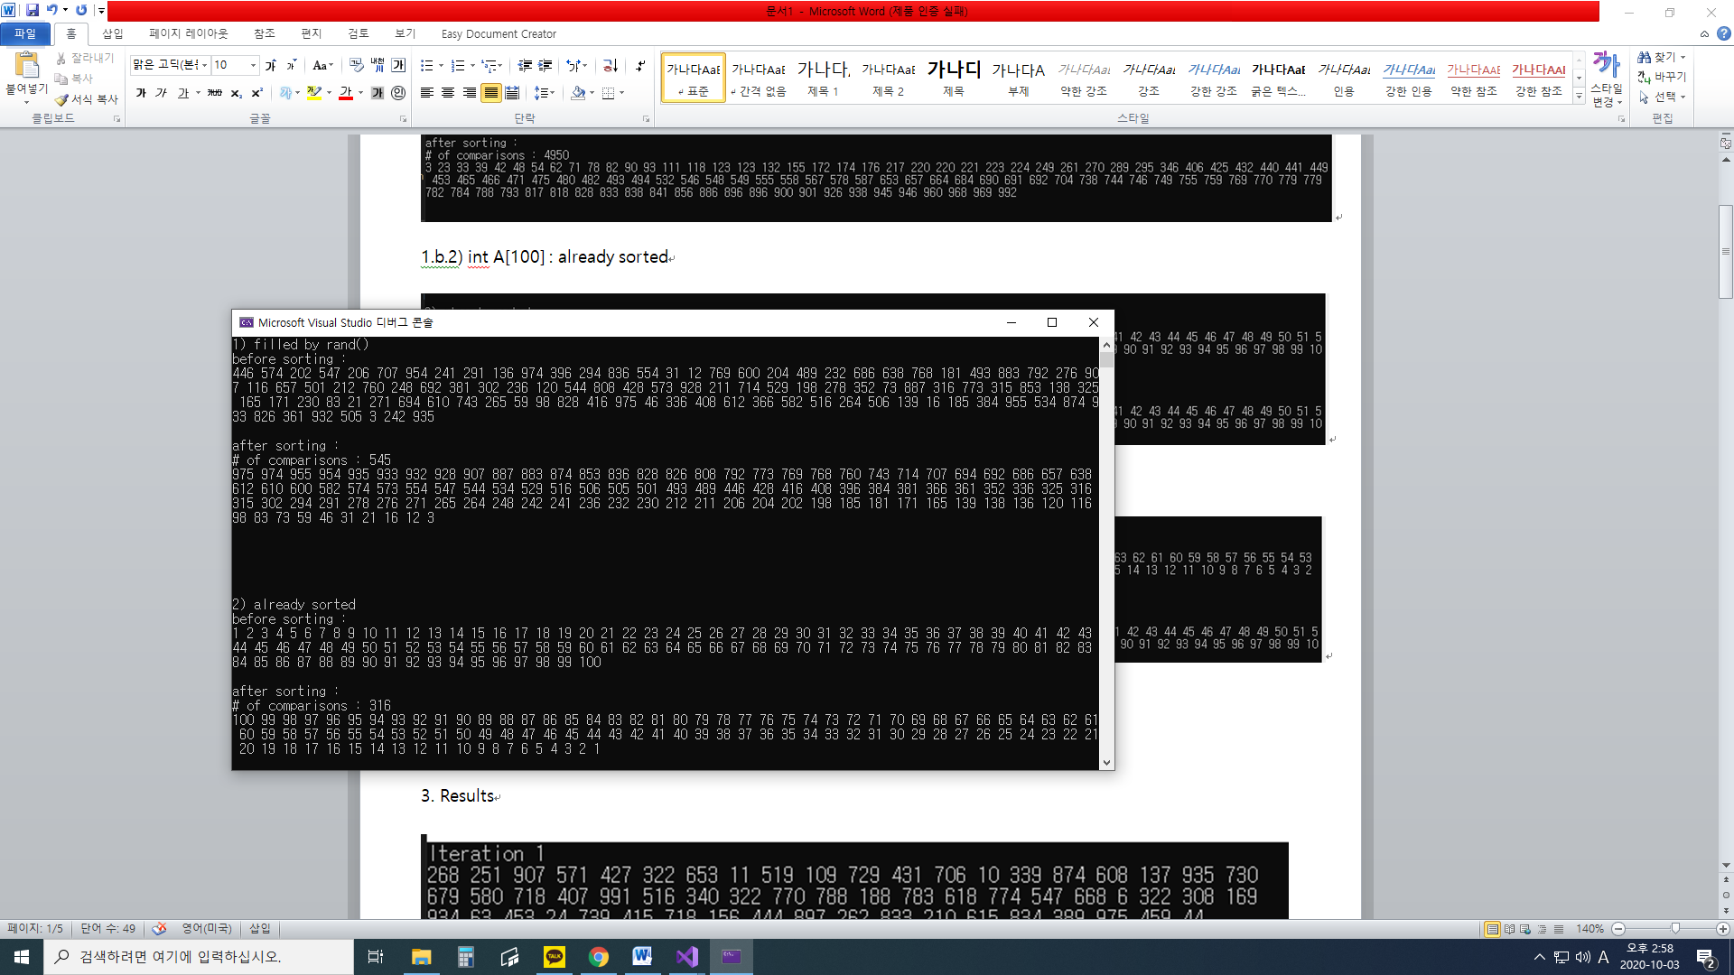

2.2) int A[100] : already sorted (from 100 down to 1)

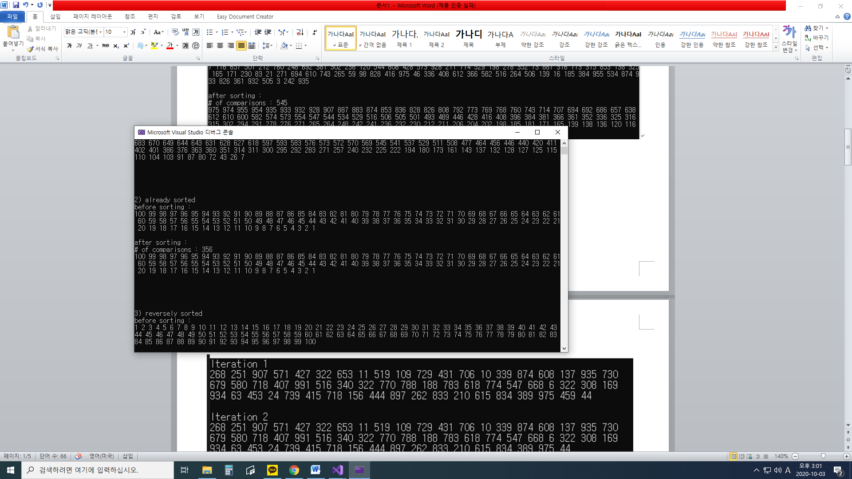

2.3) int A[100] : reversely sorted(from 1 too 100)

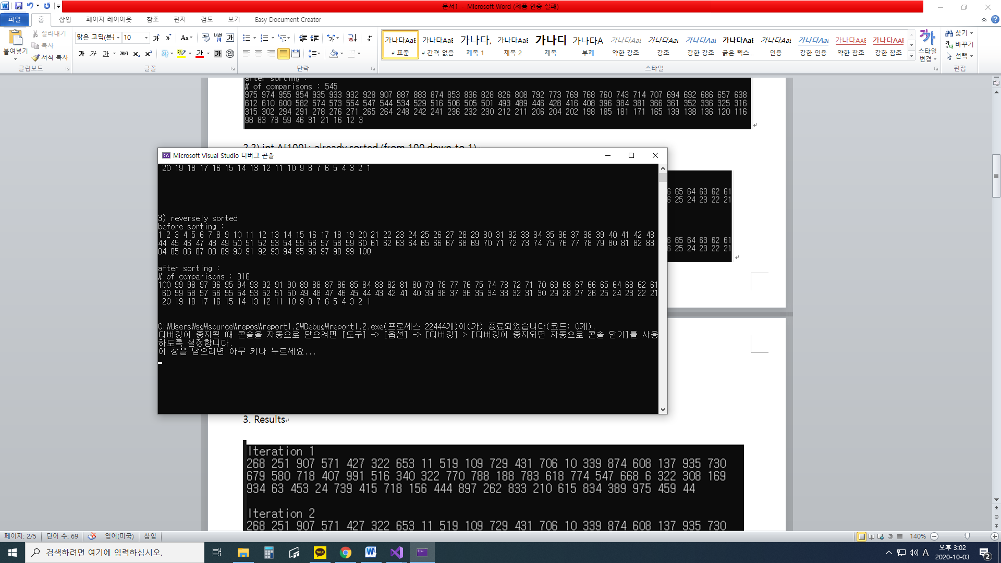

3. Results

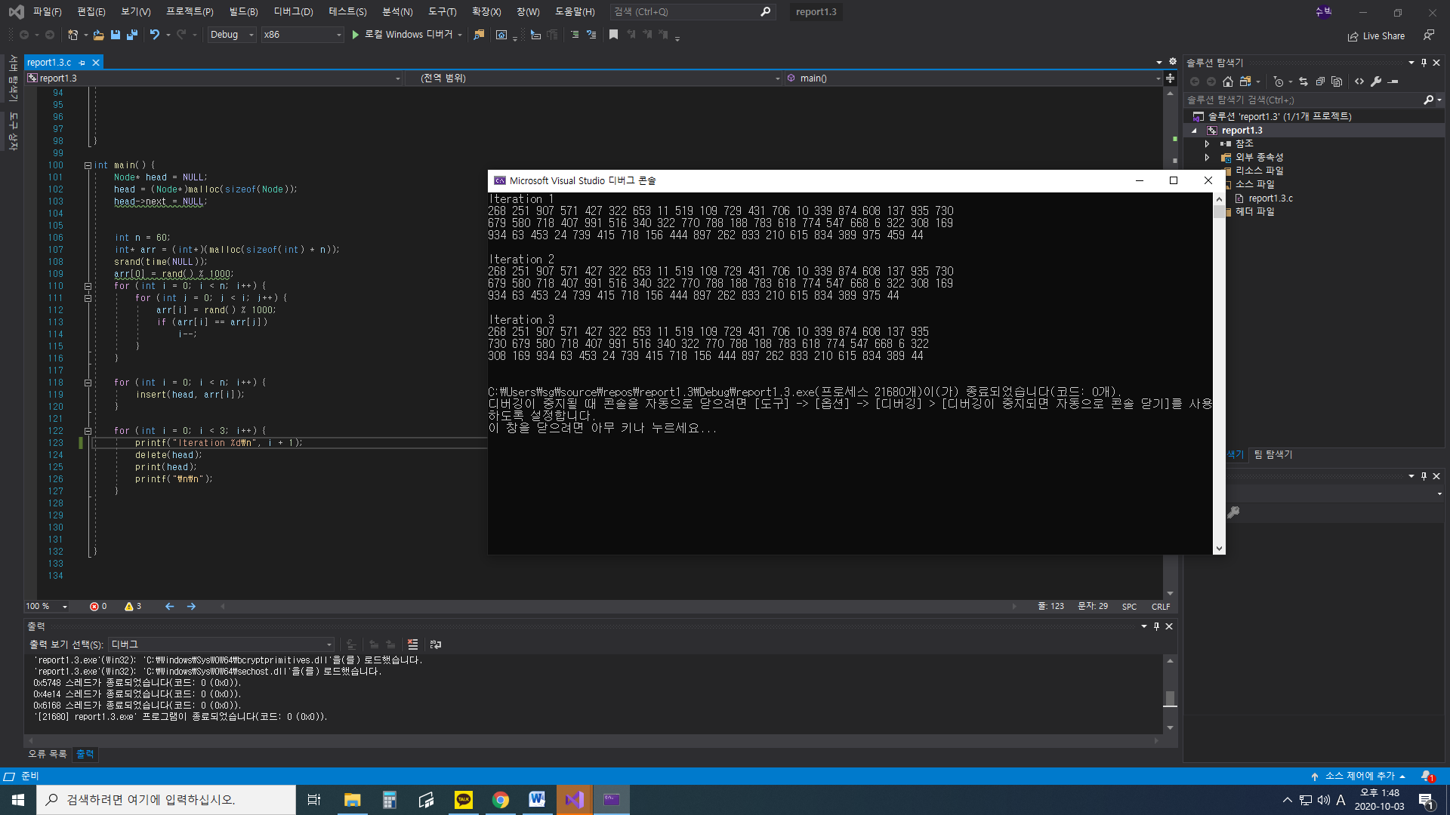

4.1) Matrix multiplication using standard algorithm

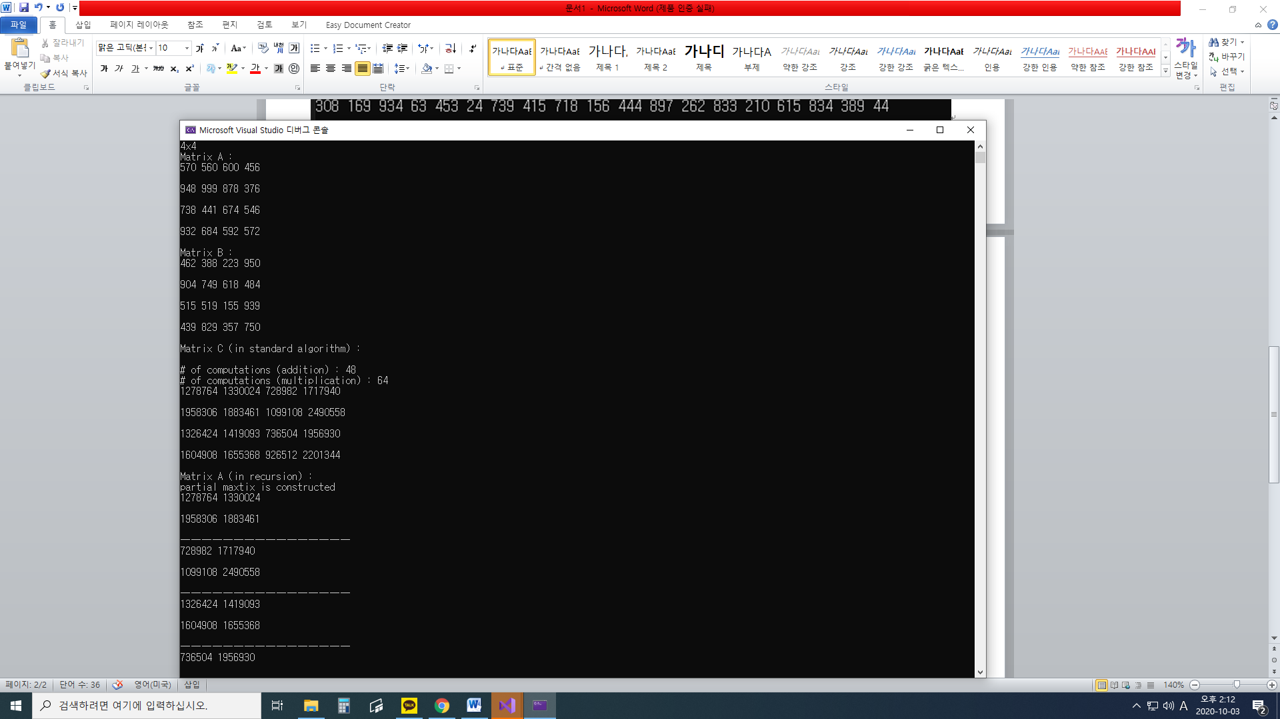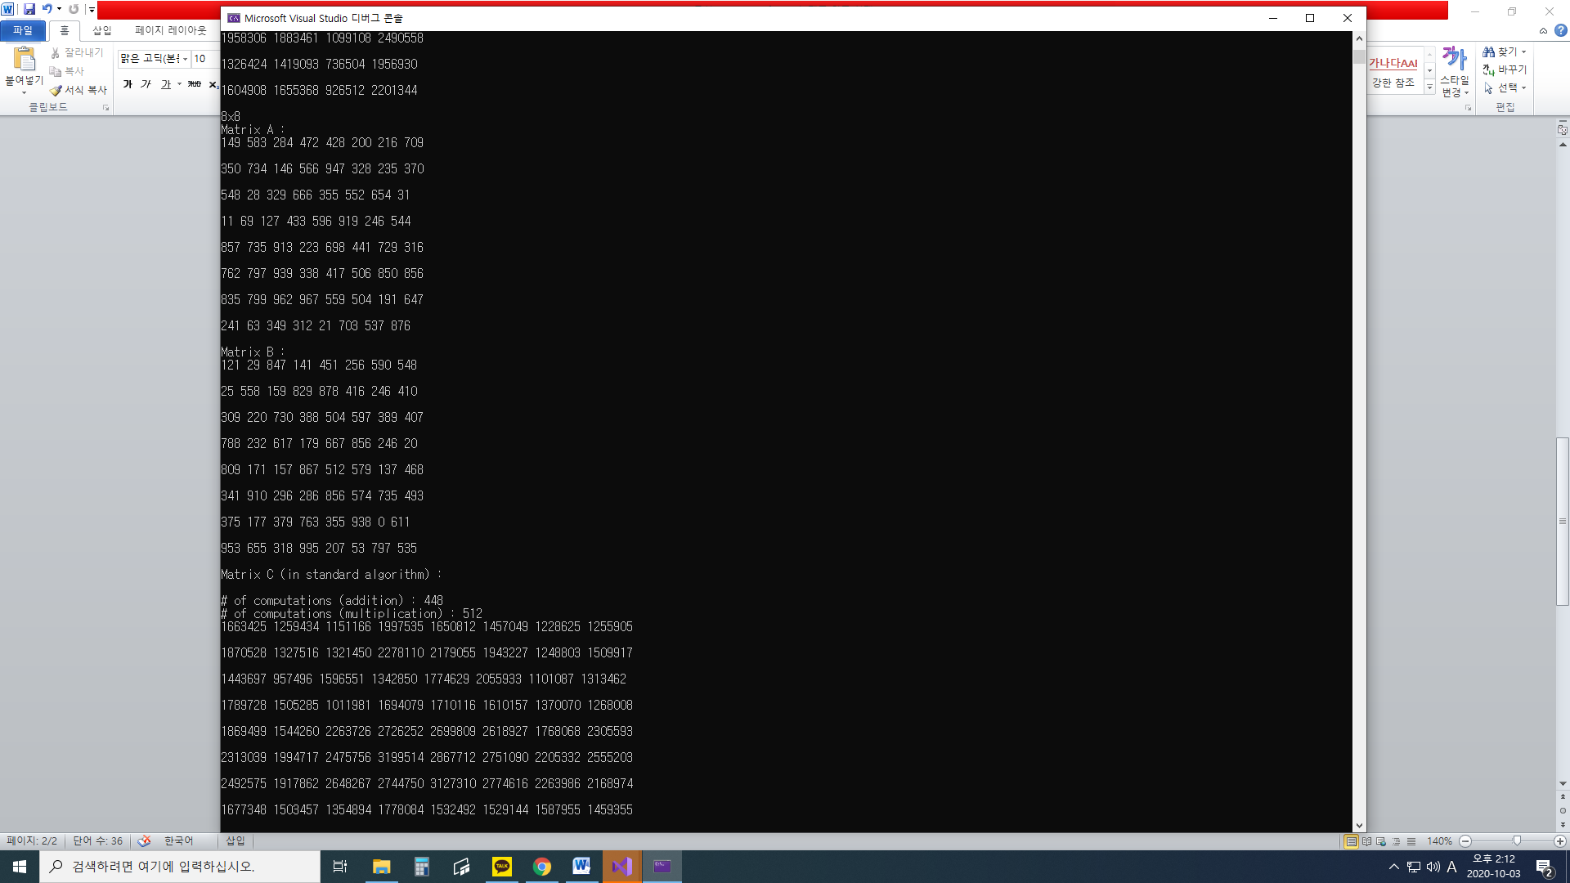

4.2) Matrix multiplication using recursion

4x4 :

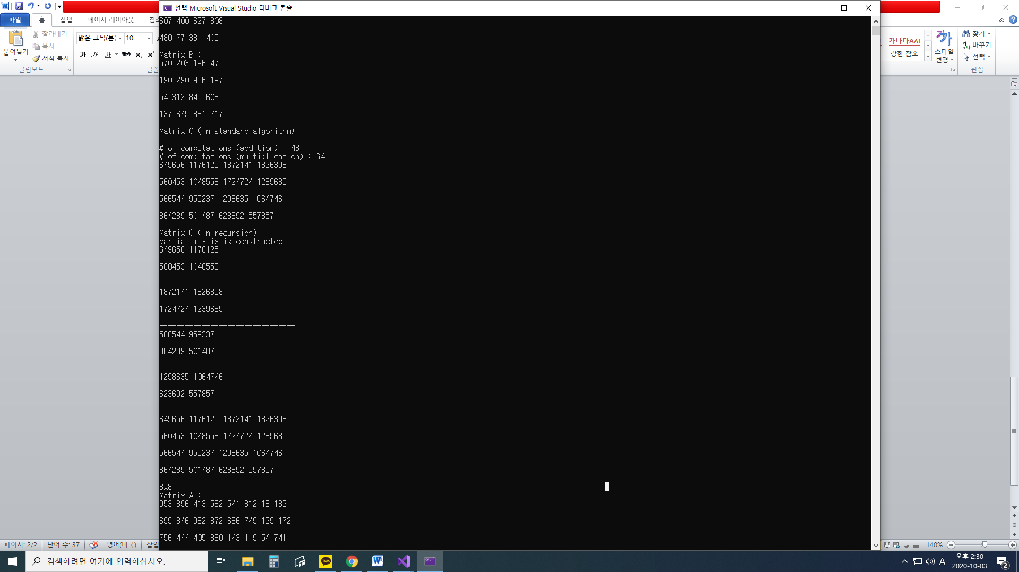

Number of multiplications when multiplying 2x2 matrix is 8, and the number of additions when multiplying 2x2 matrix is 4.

Therefore multiplying 4x4 matrices recursively means that 8 multiplications and 4 additions will happen when each partition multiplication happens.

Accordingly, in 4x4 matrices case, multiplications happen 8*8 = 64 times, and additions happen 8*4+4 = 68 times.

In 8x8 matrices case, multiplications happen 8*8*8 = 512 times, and additions happen 8*((8*4)+4)+4 = 292 times.

According to 4.1) which used a standard algorithm method, following is the number of computations comparison.

|  |  |  |  |  |
| --- | --- | --- | --- | --- |
|  | 4x4 | | 8x8 | |
| Standard Algorithm | Recursion | Standard Algorithm | Recursion |
| Multiplication | 64 | 64 | 512 | 512 |
| Addition | 48 | 68 | 448 | 292 |
| Total | 112 | 132 | 960 | 804 |

8x8 :

